10 September 2020

Lab 1

1. $ ssh
   1. $ssh cs45aa06@209.129.148.10
2. $ id
   1. uid=1006(cs45aa06) gid=1006(cs45aa06) groups=1006(cs45aa06) context=unconfined_u:unconfined_r:unconfined_t:s0-s0:c0.c1023
3. $ id -r/-u
   1. $id -r
      1. Real user id: who you actually are before switching users
         1. id: cannot print only names or real IDs in default format
   2. $id -u
      1. Effective user id: who you currently are
         1. 1006
4. $ who
   1. 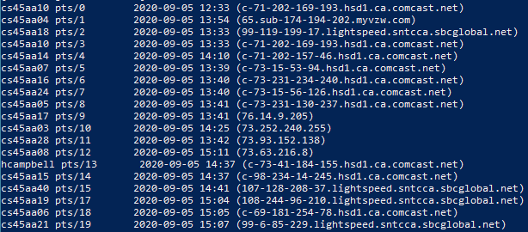
   2. 2020-09-05 14:37 (c-73-41-184-155.hsd1.ca.comcast.net)
5. $ tty
   1. /dev/pts/18
6. $ w
   1. 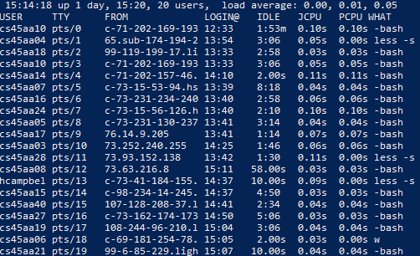
7. $ man w
   1. 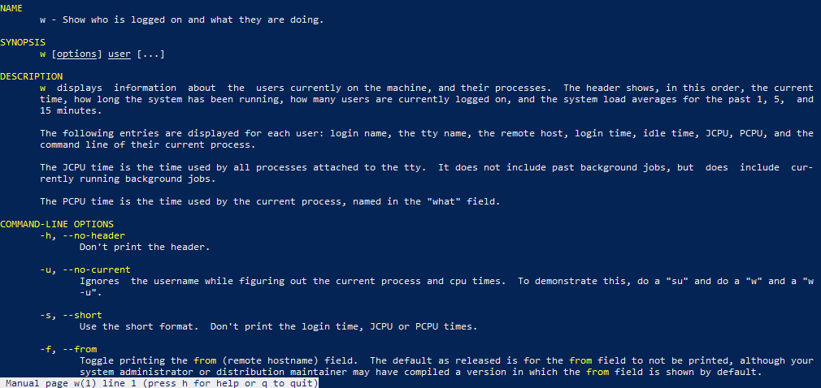
8. $ info man
   1. 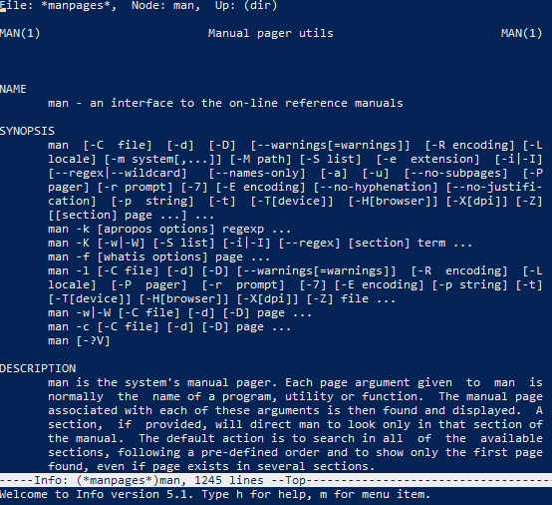
9. $ hostname
   1. mc-redhat01
10. $ hostname --help
    1. 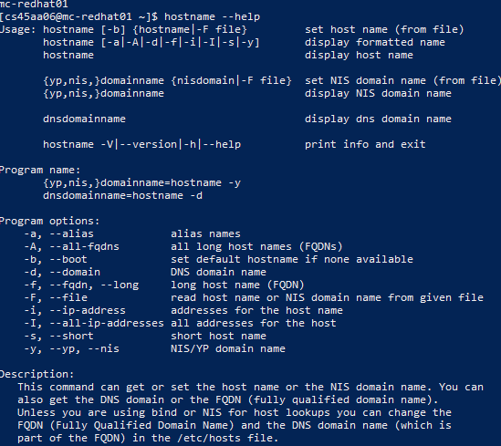
    2. -i, --ip-address
    3. long host name (FQDN)
11. $ man -k
    1. $ man -s3p printf
    2. man printf just shows the options for printf(1) while man -s3p printf shows the full manual for the specific command
    3. printf(1)
12. 'curl'
    1. Curl is a tool to transfer data from or to a server, using one of the supported protocols
13. 'wget'
    1. GNU Wget is a free utility for non-interactive download of files from the Web
14. $ echo $0
    1. -bash
15. $ echo $SHELL
    1. /bin/bash
16. $ echo $PATH
    1. /usr/local/bin:/usr/bin:/usr/local/sbin:/usr/sbin:/home/cs45aa06/.local/bin:/home/cs45aa06/bin
17. $ pizza
    1. bash: pizza: command not found…
18. $ su - mr-tester
    1. $ pwd
       1. /home/mr-tester
    2. $ whoami
       1. mr-tester
    3. $ who am i
       1. cs45aa06 pts/0
    4. $ whoami shows which user you are currently accessing and $ who am i displays the name of your real user
    5. $ whoami
       1. cs45aa06
19. $ su mr-tester
    1. $ pwd
       1. /home/cs45aa06
    2. $ whoami
       1. mr-tester
    3. $ who am i
       1. cs45aa06 pts/0
    4. The working directory points to my own user instead of mr-tester’s
    5. $ whoami
       1. cs45aa06
20. $ last
    1. 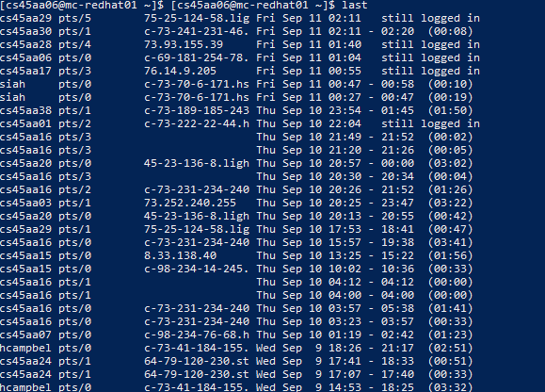
    2. $ last mr-tester
       1. wtmp begins Thu Sep 3 23:10:23 2020
21. $ pinky
    1. $ pinky cs45aa06
       1. 
    2. $ pinky -l cs45aa06
       1. 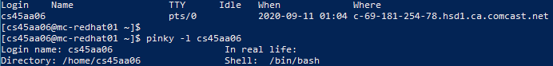
22. $ cal
    1. $ cal 2020
       1. 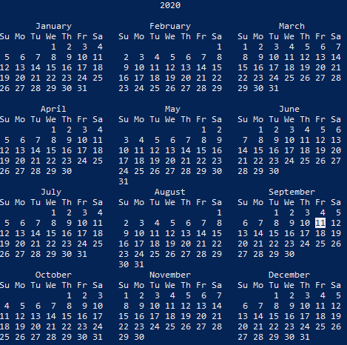
    2. $ cal 1999
       1. 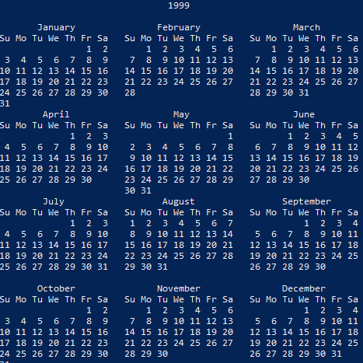
    3. cal 10 2025
       1. 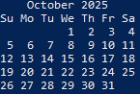
23. $ date
    1. $ date
       1. Fri Sep 11 02:31:08 EDT 2020
    2. $ date +%F
       1. 2020-09-11
    3. $ date +%m
       1. 09
    4. $ date +%m-%d
       1. 09-11
    5. 09-05-2020
       1. date +%m-%d-%y
24. $ pwd
    1. $ pwd
       1. /home/cs45aa06
    2. $ dir
       1. Using ‘dir’ on it’s own returns nothing
       2. The command’s purpose is to list directory contents
25. $ pwd
    1. $ pwd
       1. /home/cs45aa06
    2. $ cd /tmp
       1. $ pwd
          1. /tmp
       2. $ ls
          1. 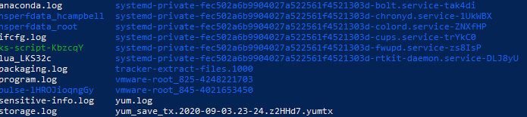
    3. $ ls -a
       1. 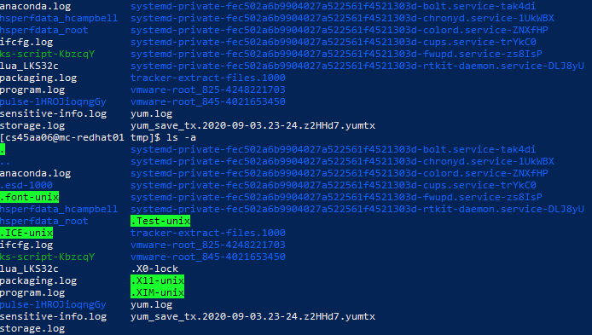
    4. $ cd /
       1. $ ls -F
          1. bin@ boot/ dev/ etc/ home/ lib@ lib64@ media/ mnt/ opt/ proc/ root/ run/ sbin@ srv/ sys/ tmp/ usr/ var/
    5. $ cd /tmp; ls -a; pwd; date
       1. 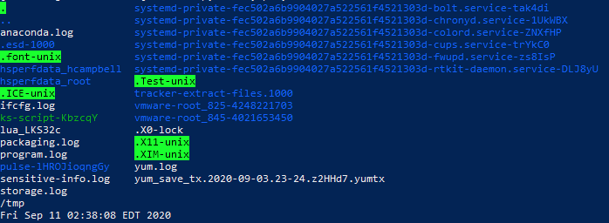
26. $ cd
    1. $ cd ~ ; ls -l
       1. total 0
    2. $ cd ; ls -al
       1. 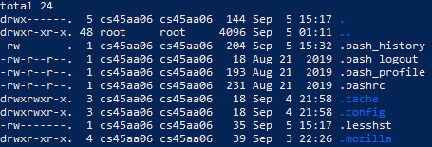
    3. $ cd $HOME; ls -a
       1. . .. .bash_history .bash_logout .bash_profile .bashrc .cache .config .lesshst .mozilla
    4. $ cd /tmp; pwd
       1. /tmp
    5. $ cd - ; pwd
       1. /home/cs45aa06
       2. /home/cs45aa06
       3. Adding a dash returns you to the directory you were in previously
    6. $ cd ~mr-tester ; pwd
       1. /home/mr-tester
    7. $ cd /; ls
       1. bin boot dev etc home lib lib64 media mnt opt proc root run sbin srv sys tmp usr var
    8. $ cd ~; pwd
       1. /home/cs45aa06
    9. $ cd .. ; pwd
       1. /home
       2. It takes you to the parent directory
    10. $ pwd; cd ~
        1. /home
    11. $ ls -a .
        1. . .. .bash_history .bash_logout .bash_profile .bashrc .cache .config .lesshst .mozilla
27. Memory
    1. $ free
       1. 
    2. $ free -h
       1. 
    3. $ free --help ; man free
       1. 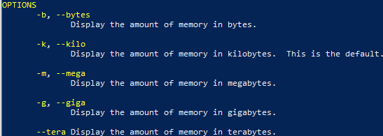
       2. $ free -g
          1. 
       3. $ free -b
          1. 
28. ‘ls’
    1. $ type ls
       1. ls is aliased to `ls --color=auto'
    2. $ type pwd
       1. pwd is a shell builtin
    3. $ type date
       1. date is hashed (/usr/bin/date)
29. How much space is being used by each file system on this node?
    1. $ df -h
       1. 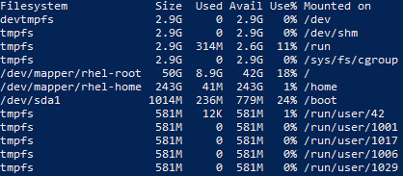
    2. $ df -hT
       1. 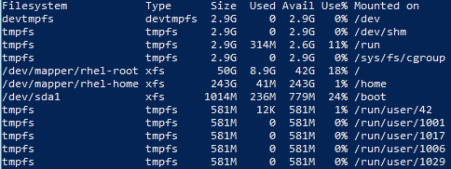
30. How much space is being used by the files and directories on the disk?
    1. $ du
       1. 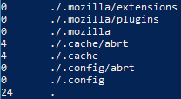
    2. $ du -sh .
       1. 24K .
    3. $ du -sh *
       1. du: cannot access ‘*’: No such file or directory
    4. $ du -a
       1. 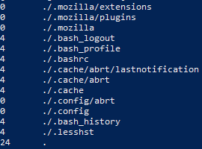
    5. $ du -sh /home
       1. 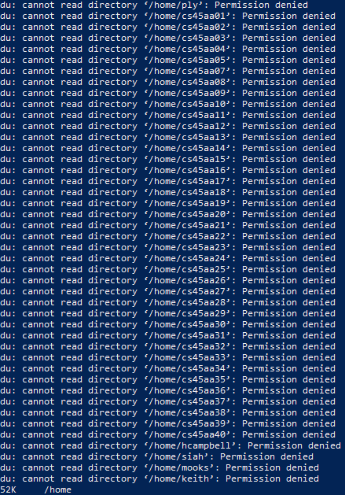
    6. $ du -shS /home
       1. 